- Introduction to SQL
Theory Questions:
1. What is SQL, and why is it essential in database management?
SQL (Structured Query Language) is a standard programming language used to store, manage, and retrieve data from databases.
Why it is essential:
- It allows users to insert, update, delete, and read data easily.
- It helps in managing large amounts of data efficiently.
- It provides security through permissions and user controls.
- It is used by almost all relational databases like MySQL, Oracle, SQL Server, PostgreSQL, etc.

2. Explain the difference between DBMS and RDBMS.
DBMS (Database Management System):
- Stores data in files or non-relational format.
- Does not support relationships between tables.
- Example: Microsoft Access, File System.
RDBMS (Relational Database Management System):
- Stores data in tables that are related using keys (Primary Key & Foreign Key).
- Follows ACID properties to ensure data accuracy.
- Supports relationships, constraints, and normalization.
- Examples: MySQL, Oracle, SQL Server, PostgreSQL.
Key Difference:
DBMS handles data without relationships, while RDBMS handles data with relationships using tables.

3. Describe the role of SQL in managing relational databases.
SQL plays a major role in managing relational databases by allowing users to:
- Create tables and database structures (DDL).
- Insert, update, delete records (DML).
- Retrieve specific data using queries (SELECT).
- Control user access and security (DCL).
- Manage transactions to ensure data correctness (TCL).
In simple terms, SQL acts as a bridge between the user and the database, helping perform all database operations.

4. What are the key features of SQL?
Here are the main features:
- Data Retrieval: Using SELECT queries.
- Data Manipulation: INSERT, UPDATE, DELETE.
- Data Definition: CREATE, ALTER, DROP tables.
- Data Control: GRANT, REVOKE permissions.
- Transaction Control: COMMIT, ROLLBACK, SAVEPOINT.
- High Performance: Fast and efficient data operations.
- Portability: Works on different systems and platforms.
- Standard Language: Used universally in almost all relational databases
LAB EXERCISES:
• Lab 1: Create a new database named school_db and a table called students with the following columns: student_id, student_name, age, class, and address.
Create a new database
Query : create database school_db;
Switch to the database
Query : USE school_db;
Create the students table
Query :
CREATE TABLE students (
student_id INT PRIMARY KEY,
student_name VARCHAR(50),
age INT,
class VARCHAR(10),
address VARCHAR(100)
);
Describe table
Query :
DESC students;
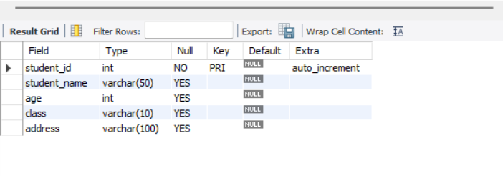
• Lab 2: Insert five records into the students table and retrieve all records using the SELECT statement.
Query :
INSERT INTO students (student_name, age, class, address)
VALUES
('Rahul Sharma', 14, '8A', 'Surat'),
('Priya Patel', 15, '9B', 'Mumbai'),
('Amit Kumar', 13, '7C', 'Delhi'),
('Sneha Verma', 14, '8B', 'Ahmedabad'),
('Chetan Patil', 15, '9A', 'Jalgaon');

Query :
select *from students;
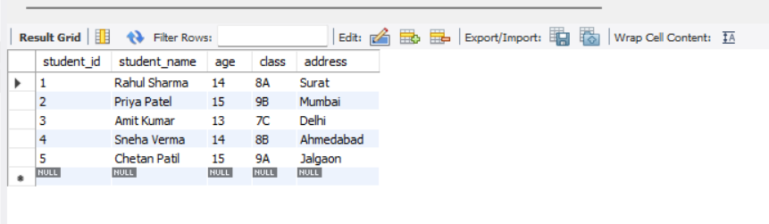
- SQL Syntax
Theory Questions:
- What are the basic components of SQL syntax?
The basic components of SQL syntax include:
- Keywords (SELECT, INSERT, UPDATE, DELETE, WHERE, FROM, etc.)
- Identifiers (table names, column names)
- Operators (=, >, <, AND, OR, LIKE, IN, etc.)
- Clauses (WHERE clause, ORDER BY clause, GROUP BY clause)
- Expressions & Conditions (used for filtering and calculations)
- Statements (complete SQL commands like SELECT, INSERT, UPDATE)

- Write the general structure of an SQL SELECT statement.
SELECT column1, column2, ...
FROM table_name
WHERE condition
GROUP BY column
HAVING condition
ORDER BY column ASC|DESC;
- Explain the role of clauses in SQL statements. LAB EXERCISES:
Clauses are used to add additional instructions to an SQL query.
They help in:
- Filtering data → WHERE clause
- Sorting data → ORDER BY clause
- Grouping data → GROUP BY clause
- Filtering grouped data → HAVING clause
- Choosing table → FROM clause

• Lab 1: Write SQL queries to retrieve specific columns (student_name and age) from the students table.
Query :
SELECT student_name, age
FROM students;
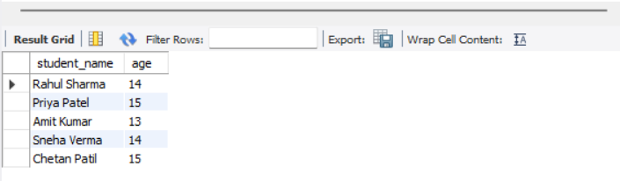
• Lab 2: Write SQL queries to retrieve all students whose age is greater than 10.
Qurey :
SELECT *
FROM students
WHERE age > 10;

3. SQL Constraints
Theory Questions:
1. What are constraints in SQL? List and explain the different types of constraints.
Constraints are rules applied to table columns to maintain data accuracy, integrity, and reliability in a database.
Types of SQL Constraints:
- PRIMARY KEY
  - Uniquely identifies each record in a table.
  - No duplicates allowed, and cannot be NULL.
- FOREIGN KEY
  - Creates a relationship between two tables.
  - Ensures the value in child table exists in parent table.
- NOT NULL
  - Ensures a column cannot accept NULL values.
- UNIQUE
  - Ensures all values in a column are different.
- CHECK
  - Ensures values meet a specific condition.
  - Example: CHECK(age > 5)
- DEFAULT
  - Assigns a default value when no value is provided.

2. How do PRIMARY KEY and FOREIGN KEY constraints differ?
PRIMARY KEY | FOREIGN KEY
Uniquely identifies a row in its own table | Refers to the PRIMARY KEY of another table
Cannot contain NULL values | Can contain NULL (unless NOT NULL is applied)
Only one primary key per table | Multiple foreign keys allowed
Ensures row uniqueness | Ensures referential integrity between tables

3. What is the role of NOT NULL and UNIQUE constraints?
NOT NULL Constraint
- Ensures the column must have a value.
- Prevents empty (NULL) entries.
UNIQUE Constraint
- Ensures all values are different in that column.
- Allows one NULL value (depending on DBMS).
Example:
- Email should be UNIQUE (no two users should have the same email)
- Name may be NOT NULL (must always be provided)

LAB EXERCISES:
• Lab 1: Create a table teachers with the following columns: teacher_id (Primary Key), teacher_name (NOT NULL), subject (NOT NULL), and email (UNIQUE).
Create teachers table with constraints
Query :
CREATE TABLE teachers (
teacher_id INT PRIMARY KEY,
teacher_name VARCHAR(50) NOT NULL,
subject VARCHAR(50) NOT NULL,
email VARCHAR(100) UNIQUE
);
DESC teachers;
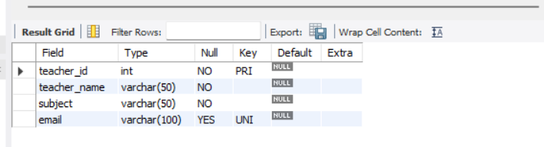
• Lab 2: Implement a FOREIGN KEY constraint to relate the teacher_id from the teachers table with the students table.
Add teacher_id column in students table
Query :
ALTER TABLE students
ADD teacher_id INT;
Add FOREIGN KEY constraint linking to teachers table
Query:
ALTER TABLE students
ADD CONSTRAINT fk_teacher
FOREIGN KEY (teacher_id)
REFERENCES teachers(teacher_id);
Describe student table :
Query:
desc students;
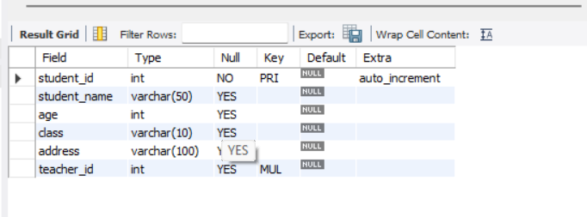

4. Main SQL Commands and Sub-commands (DDL)
Theory Questions:
1. Define the SQL Data Definition Language (DDL).
DDL (Data Definition Language) is a category of SQL commands used to define, create, modify, and delete database structures, such as databases, tables, indexes, and views.
Common DDL commands include:
- CREATE – to create databases and tables
- ALTER – to modify existing database objects
- DROP – to delete database objects
- TRUNCATE – to remove all data from a table
- RENAME – to rename database objects
DDL commands automatically commit changes to the database.

2. Explain the CREATE command and its syntax.
The CREATE command is used to create new database objects, such as databases, tables, views, or indexes.
General Syntax for creating a table:
CREATE TABLE table_name (
column1 datatype constraint,
column2 datatype constraint,
column3 datatype constraint,
...
);
General Syntax for creating a database:
CREATE DATABASE database_name;

3. What is the purpose of specifying data types and constraints during table creation?
Purpose of Data Types
- Defines what type of data a column can store (e.g., INT, VARCHAR, DATE).
- Helps the database optimize storage and improve performance.
- Prevents invalid data from being inserted.
Purpose of Constraints
- Maintains data accuracy and reliability.
- Ensures rules such as:
  - No duplicate values (UNIQUE)
  - A row is uniquely identified (PRIMARY KEY)
  - A column must have a value (NOT NULL)
  - Valid relationships between tables (FOREIGN KEY)
In short, data types define the type of data, while constraints define rules for that data.

LAB EXERCISES:
• Lab 1: Create a table courses with columns: course_id, course_name, and course_credits. Set the course_id as the primary key.
Query :
CREATE TABLE courses (
course_id INT PRIMARY KEY,
course_name VARCHAR(100),
course_credits INT
);
Desc courses;
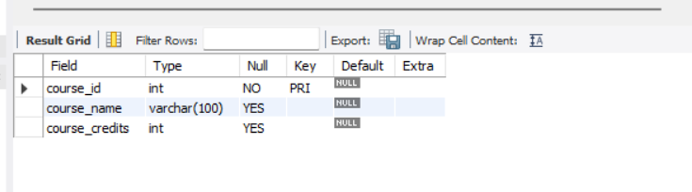
• Lab 2: Use the CREATE command to create a database university_db.
Query :
CREATE DATABASE university_db;

5. ALTER Command
Theory Questions:
1. What is the use of the ALTER command in SQL?
The ALTER command is a DDL (Data Definition Language) command used to modify the structure of an existing table without deleting it.
You can use ALTER to:
- Add new columns
- Modify existing columns
- Delete (drop) columns
- Add or remove constraints
- Rename columns or tables
In short, ALTER is used to change the structure of a table after it has been created.

2. How can you add, modify, and drop columns from a table using ALTER?
Add a column
ALTER TABLE table_name
ADD column_name datatype;
Modify (change) a column
ALTER TABLE table_name
MODIFY column_name new_datatype;
Drop (delete) a column
ALTER TABLE table_name
DROP COLUMN column_name;

LAB EXERCISES:
• Lab 1: Modify the courses table by adding a column course_duration using the ALTER command.
ALTER TABLE courses
ADD course_duration VARCHAR(50);
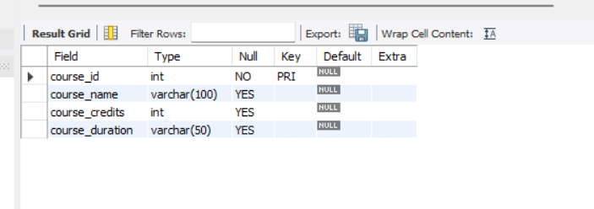
• Lab 2: Drop the course_credits column from the courses table.
ALTER TABLE courses
DROP COLUMN course_credits;
desc courses;
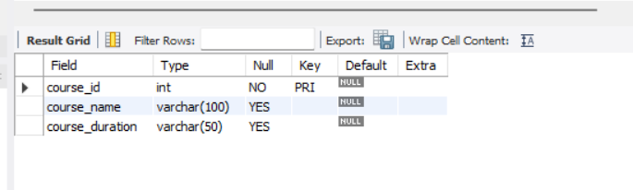

6. DROP Command
Theory Questions:
1. What is the function of the DROP command in SQL?
The DROP command is a DDL (Data Definition Language) command used to permanently delete database objects, such as tables, databases, views, or indexes.
When you drop an object:
- It is removed permanently
- All data stored inside it is deleted
- The action cannot be undone
2. What are the implications of dropping a table from a database?
Dropping a table has the following effects:
❌ Permanent Deletion
- The table structure and the data inside it are completely removed.
❌ Cannot be Undone
- DROP is irreversible – you cannot recover the dropped table unless you have a backup.
❌ Dependent Constraints Are Affected
- Any foreign key relationships connected to the table will break or cause errors unless dropped first.
✔ Frees Storage Space
- Physical storage used by the table is released.
In short: Dropping a table removes it fully and permanently from the database.

LAB EXERCISES:
• Lab 1: Drop the teachers table from the school_db database.
Query:
DROP TABLE teachers;
• Lab 2: Drop the students table from the school_db database and verify that the table has been removed.
Query:
DROP TABLE students;
SHOW TABLES;
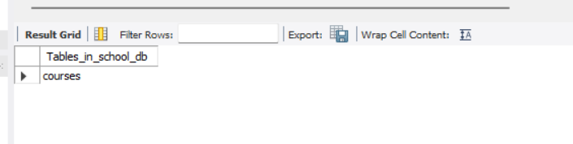
7. Data Manipulation Language (DML)
Theory Questions:
1. Define the INSERT, UPDATE, and DELETE commands in SQL.
INSERT Command
The INSERT command is used to add new records (rows) into a table.
Example:
INSERT INTO table_name (column1, column2) VALUES (value1, value2);

UPDATE Command
The UPDATE command is used to modify existing records in a table.
Example:
UPDATE table_name SET column1 = value WHERE condition;

DELETE Command
The DELETE command is used to remove records from a table.
Example:
DELETE FROM table_name WHERE condition;

2. What is the importance of the WHERE clause in UPDATE and DELETE operations?
The WHERE clause is extremely important because it:
✔ Prevents updating or deleting all rows accidentally
If you don't use WHERE:
- UPDATE will modify every row
- DELETE will delete all rows
✔ Specifies the exact record(s) to change
It ensures only the targeted record(s) are affected.
✔ Protects data integrity
Avoids accidental loss or incorrect modification of large amounts of data.
Example:
UPDATE courses SET course_duration = '6 months' WHERE course_id = 1;
Without WHERE → all courses get updated.
LAB EXERCISES:
• Lab 1: Insert three records into the courses table using the INSERT command.
Query:
INSERT INTO courses (course_id, course_name, course_duration)
VALUES
(101, 'Computer Basics', '3 months'),
(102, 'Advanced Java', '6 months'),
(103, 'Database Management', '4 months');
Query:
select *from courses;
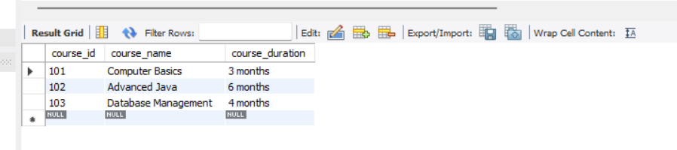
• Lab 2: Update the course duration of a specific course using the UPDATE command.
Query:
UPDATE courses
SET course_duration = '7 months'
WHERE course_id = 102;

select *from courses;

• Lab 3: Delete a course with a specific course_id from the courses table using the DELETE command.
Query:
DELETE FROM courses
WHERE course_id = 101;

select *from courses;
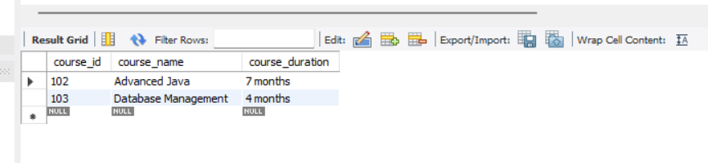
8. Data Query Language (DQL)
Theory Questions:
1. What is the SELECT statement, and how is it used to query data?
The SELECT statement is the main command in SQL used to retrieve data from a database table.
It allows you to:
- Select specific columns
- Select all columns
- Filter data using conditions
- Sort data
- Limit results
Basic Syntax:
SELECT column1, column2
FROM table_name;
To select all columns:
SELECT * FROM table_name;

2. Explain the use of the ORDER BY and WHERE clauses in SQL queries.
ORDER BY Clause
Used to sort the result set in ascending (ASC) or descending (DESC) order.
Example:
SELECT * FROM courses
ORDER BY course_duration DESC;
WHERE Clause
Used to filter records based on a condition.
Example:
SELECT * FROM courses
WHERE course_duration = '3 months';
Summary
- WHERE filters rows
- ORDER BY sorts rows

LAB EXERCISES:
• Lab 1: Retrieve all courses from the courses table using the SELECT statement.
Query:
select *from courses;

• Lab 2: Sort the courses based on course_duration in descending order using ORDER BY.
Query:
SELECT *
FROM courses
ORDER BY course_duration DESC;
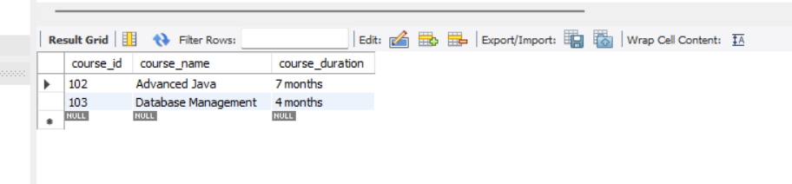
• Lab 3: Limit the results of the SELECT query to show only the top two courses using LIMIT.
Query:
SELECT *FROM courses LIMIT 2;


9. Data Control Language (DCL)
Theory Questions:
1. What is the purpose of GRANT and REVOKE in SQL?
GRANT
The GRANT command is used to give permissions to users so they can perform operations on database objects such as tables, views, or databases.
Examples of permissions:
- SELECT
- INSERT
- UPDATE
- DELETE
- ALL PRIVILEGES
- REVOKE
- The REVOKE command is used to remove permissions previously granted to a user.
- Together, GRANT and REVOKE help in controlling database security and managing who can access or modify data.

2. How do you manage privileges using these commands?
To manage privileges:
✔ Use GRANT to give permissions
Example:
GRANT SELECT ON table_name TO user1;
✔ Use REVOKE to remove permissions
Example:
REVOKE SELECT ON table_name FROM user1;
✔ You can give multiple permissions
GRANT SELECT, INSERT ON courses TO user1;
✔ You can also give all privileges
GRANT ALL PRIVILEGES ON database_name.* TO user1;
Managing privileges ensures security, controlled access, and data protection.

LAB EXERCISES:
• Lab 1: Create two new users user1 and user2 and grant user1 permission to SELECT from the courses table.
Query:
✔ Create users:
CREATE USER 'user1'@'localhost' IDENTIFIED BY 'password1';
CREATE USER 'user2'@'localhost' IDENTIFIED BY 'password2';
✔ Grant SELECT permission on courses table to user1:
GRANT SELECT ON school_db.courses TO 'user1'@'localhost';
Apply changes:
FLUSH PRIVILEGES;

• Lab 2: Revoke the INSERT permission from user1 and give it to user2.
Query:
✔ Revoke INSERT permission from user1:
REVOKE INSERT ON school_db.courses FROM 'user1'@'localhost';
✔ Grant INSERT permission to user2:
GRANT INSERT ON school_db.courses TO 'user2'@'localhost';
Apply changes:
FLUSH PRIVILEGES;
10. Transaction Control Language (TCL)
Theory Questions:
1. What is the purpose of the COMMIT and ROLLBACK commands in SQL?
COMMIT
- The COMMIT command is used to permanently save all changes made during the current transaction.
- After COMMIT, the changes cannot be undone.
ROLLBACK
- The ROLLBACK command is used to undo changes made in the current transaction.
- It restores the database to the last committed state.
- Useful when an error occurs or wrong data is inserted.
In short:
✔ COMMIT = Save changes permanently
✔ ROLLBACK = Undo changes

2. Explain how transactions are managed in SQL databases.
A transaction is a group of SQL operations that are treated as one single unit.
A transaction must follow ACID properties:
- Atomicity – All steps succeed or all fail
- Consistency – Database remains valid
- Isolation – Transactions don’t conflict
- Durability – Changes remain after COMMIT
Transaction Flow:
- Start a transaction → (START TRANSACTION or automatically starts)
- Perform SQL operations → (INSERT, UPDATE, etc.)
- Use COMMIT → Save changes permanently
- OR use ROLLBACK → Undo changes
- SAVEPOINTS allow partial rollback inside a transaction
Transaction control ensures safe and accurate database updates.

LAB EXERCISES:
• Lab 1: Insert a few rows into the courses table and use COMMIT to save the changes.
Query:
START TRANSACTION;

INSERT INTO courses (course_id, course_name, course_duration)
VALUES
(201, 'Python Basics', '2 months'),
(202, 'Web Development', '3 months');

COMMIT;
select *from courses;
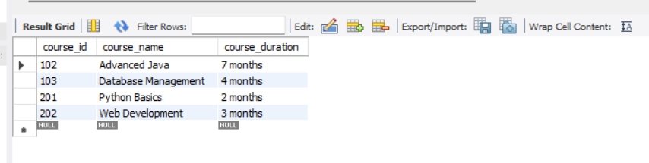
• Lab 2: Insert additional rows, then use ROLLBACK to undo the last insert operation.
Query :
START TRANSACTION;
INSERT INTO courses (course_id, course_name, course_duration)
VALUES
(203, 'Machine Learning', '4 months'),
(204, 'Cyber Security', '5 months');
ROLLBACK;
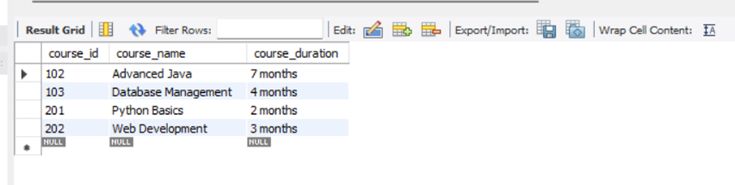
• Lab 3: Create a SAVEPOINT before updating the courses table, and use it to roll back specific changes.
START TRANSACTION;

-- Step 1: Create a SAVEPOINT
SAVEPOINT before_update;

-- Step 2: Update the table
UPDATE courses
SET course_duration = '10 months'
WHERE course_id = 201;

-- Step 3: Roll back only to the SAVEPOINT (undo update)
ROLLBACK TO before_update;

-- Step 4: Commit remaining operations
COMMIT;

select *from courses;
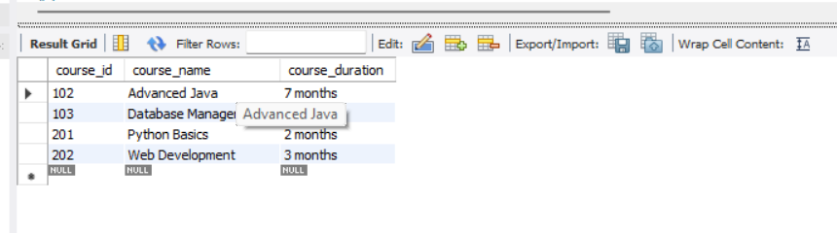
11. SQL Joins Theory Questions:
1. Explain the concept of JOIN in SQL. What is the difference between INNER JOIN, LEFT JOIN, RIGHT JOIN, and FULL OUTER JOIN?
A JOIN in SQL is used to combine rows from two or more tables based on a related column between them (usually a foreign key).
It helps retrieve connected data stored in multiple tables.
Types of Joins
a) INNER JOIN
- Returns only the matching rows from both tables.
- Rows with no match are excluded.
b) LEFT JOIN (LEFT OUTER JOIN)
- Returns all rows from the left table and the matching rows from the right table.
- If no match, right table columns show NULL.
c) RIGHT JOIN (RIGHT OUTER JOIN)
- Returns all rows from the right table and matching rows from the left table.
- If no match, left table columns show NULL.
d) FULL OUTER JOIN
- Returns all rows from both tables.
- Non-matching rows show NULL on the side where a match doesn't exist.
JOIN Type | Matching Rows | Non-Matching Rows
INNER JOIN | Only matched rows | Not shown
LEFT JOIN | Matched rows + all rows from LEFT table | Right table becomes NULL
RIGHT JOIN | Matched rows + all rows from RIGHT table | Left table becomes NULL
FULL OUTER JOIN | All matched rows | Both sides may have NULL

2. How are joins used to combine data from multiple tables?
Joins work by linking tables using a common column, often a primary key in one table and a foreign key in another.
Example:
SELECT *
FROM table1
JOIN table2
ON table1.id = table2.id;
This creates a single result set combining related data from both tables. Joins help in:
- Reducing data redundancy
- Retrieving meaningful reports
- Managing relational database structures

LAB EXERCISES:
• Lab 1: Create two tables: departments and employees. Perform an INNER JOIN to display employees along with their respective departments.
Query:
*Department table
CREATE TABLE departments (
dept_id INT PRIMARY KEY,
dept_name VARCHAR(100)
);
*Employee table
CREATE TABLE employees (
emp_id INT PRIMARY KEY,
emp_name VARCHAR(100),
dept_id INT,
FOREIGN KEY (dept_id) REFERENCES departments(dept_id)
);
*insert data in table
INSERT INTO departments VALUES
(1, 'HR'),
(2, 'Finance'),
(3, 'IT'),
(4,'SE');

INSERT INTO employees VALUES
(101, 'chetan', 1),
(102, 'jagdish', 2),
(103, 'Nikhil', 3),
(104,'mayur',4),
(105,'Ratilal',3);
**Inner join
SELECT employees.emp_id, employees.emp_name, departments.dept_name
FROM employees
INNER JOIN departments
ON employees.dept_id = departments.dept_id;
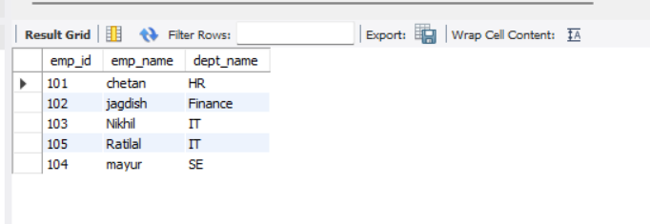
• Lab 2: Use a LEFT JOIN to show all departments, even those without employees.
SELECT departments.dept_id,
departments.dept_name,
employees.emp_name
FROM departments
LEFT JOIN employees
ON departments.dept_id = employees.dept_id;
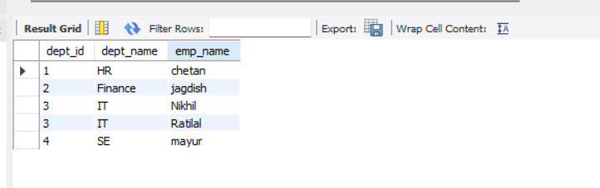

12. SQL Group By Theory Questions:
1. What is the GROUP BY clause in SQL? How is it used with aggregate functions?
The GROUP BY clause in SQL is used to arrange identical data into groups.
It is mainly used with aggregate functions such as:
- COUNT()
- SUM()
- AVG()
- MAX()
- MIN()
Purpose:
To perform calculations on each group of data instead of the entire table.
How it works:
SELECT column_name, AGGREGATE_FUNCTION(column_name)
FROM table_name
GROUP BY column_name;
Example:
Group employees by department and count employees per department.

2. Explain the difference between GROUP BY and ORDER BY.
Feature | GROUP BY | ORDER BY
Purpose | Groups rows | Sorts rows
Uses Aggregate Functions? | Yes (commonly used) | No (sorting only)
Order of Output | Does not guarantee sorted order | Always sorts ASC/DESC
Example | COUNT employees per department | Sort employees by salary

LAB EXERCISES :
• Lab 1: Group employees by department and count the number of employees in each department using GROUP BY.
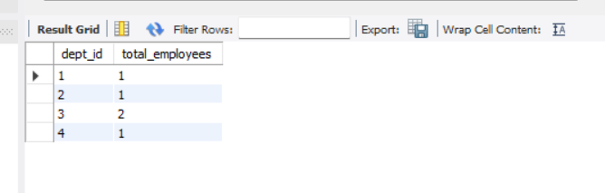
• Lab 2: Use the AVG aggregate function to find the average salary of employees in each department.
Add Salary Column
ALTER TABLE employees ADD salary INT;
Insert Salary Data for Each Employee
UPDATE employees SET salary = 30000 WHERE emp_id = 101;
UPDATE employees SET salary = 45000 WHERE emp_id = 102;
UPDATE employees SET salary = 38000 WHERE emp_id = 103;
UPDATE employees SET salary = 42000 WHERE emp_id = 104;
UPDATE employees SET salary = 25000 WHERE emp_id = 105;
Find average salary of employees per department
SELECT dept_id, AVG(salary) AS avg_salary
FROM employees
GROUP BY dept_id;
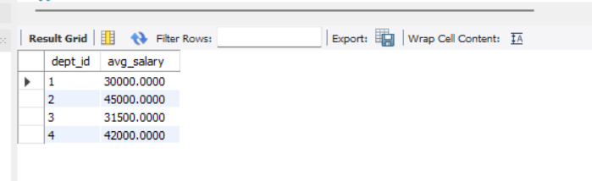
13. SQL Stored Procedure Theory Questions:
1. What is a stored procedure in SQL, and how does it differ from a standard SQL query?
A stored procedure is a precompiled block of SQL statements stored in the database and executed when called.
Difference from a standard SQL query:
Stored Procedure | Standard SQL Query
Saved permanently in database | Written & executed temporarily
Can take input (parameters) | Usually no parameters
Can include multiple SQL statements | Executes a single SQL command
More secure & faster | Less secure, slower for repeated use
Supports logic (IF, loops) | No programming logic
In short:
A stored procedure is like a function, while a normal SQL query is just a single instruction.

2. Explain the advantages of using stored procedures.
✔ Improved Performance
Stored procedures are precompiled, so they run faster than normal queries.
✔ Reusability
You can call the same procedure multiple times.
✔ Security
Users can be given permission to run procedures without accessing the actual tables.
✔ Reduced Network Traffic
Instead of sending long queries, only procedure calls are sent.
✔ Modularity
Large applications can be structured better using stored logic.

LAB EXERCISES:
• Lab 1: Write a stored procedure to retrieve all employees from the employees table based on department.
Query:
DELIMITER $$

CREATE PROCEDURE GetEmployeesByDepartment(IN dept INT)
BEGIN
SELECT emp_id, emp_name, dept_id, salary
FROM employees
WHERE dept_id = dept;
END $$

DELIMITER ;

CALL GetEmployeesByDepartment(4);
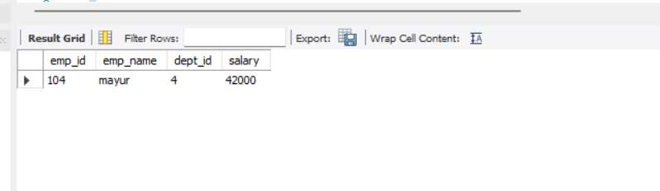

• Lab 2: Write a stored procedure that accepts course_id as input and returns the course details.
Query:
DELIMITER $$

CREATE PROCEDURE GetCourseDetails(IN cid INT)
BEGIN
SELECT *
FROM courses
WHERE course_id = cid;
END $$

DELIMITER ;

CALL GetCourseDetails(102);

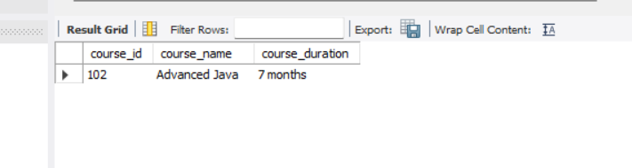

14. SQL View Theory Questions:
1. What is a view in SQL, and how is it different from a table?
A view is a virtual table created from the result of a SQL query.
It does not store data physically; it displays data stored in actual tables.
Difference Between View and Table
Table | View
Stores data physically in the database | Does NOT store data physically (virtual)
Can have INSERT, UPDATE, DELETE operations | Usually read-only (depends on DB)
Contains actual data | Only shows data fetched from tables
High storage usage | No storage (except definition)
In short:
A table stores data, and a view displays data from one or more tables.

2. Explain the advantages of using views in SQL databases.
✔ Security
Views can hide sensitive columns and show only necessary data to users.
✔ Simplicity
Complex queries can be simplified using a single view.
✔ Reusability
Views can be used repeatedly without rewriting SQL queries.
✔ Data Consistency
If the underlying table updates, the view always shows updated data.
✔ Logical Data Independence
Changes in table structure do not affect users if they use views.

LAB EXERCISES:
• Lab 1: Create a view to show all employees along with their department names.
Query:
CREATE VIEW employee_department_view AS
SELECT e.emp_id, e.emp_name, d.dept_name, e.salary
FROM employees e
INNER JOIN departments d
ON e.dept_id = d.dept_id;

SELECT * FROM employee_department_view;
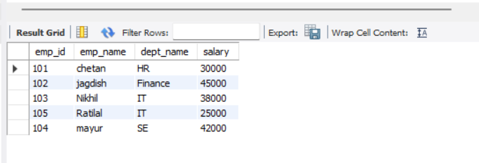
• Lab 2: Modify the view to exclude employees whose salaries are below $50,000.
Query:
CREATE VIEW employee_department_view AS
SELECT e.emp_id, e.emp_name, d.dept_name, e.salary
FROM employees e
INNER JOIN departments d
ON e.dept_id = d.dept_id
WHERE e.salary >= 50000;

SELECT * FROM employee_department_view;
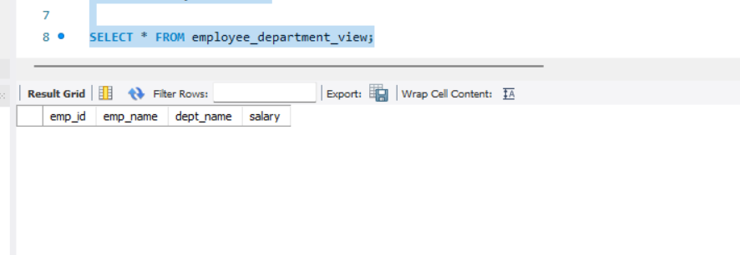
15. SQL Triggers Theory Questions:
1. What is a trigger in SQL? Describe its types and when they are used.
A trigger is a special stored program in SQL that runs automatically in response to specific events on a table (INSERT, UPDATE, DELETE).
Triggers are used for:
- Maintaining logs/audit trails
- Automatically updating fields
- Enforcing rules and data validation
- Maintaining related data in multiple tables

Types of Triggers
- BEFORE Trigger
  - Runs before the operation (INSERT/UPDATE/DELETE) is executed.
  - Used for validation or modifying data before saving.
- AFTER Trigger
  - Runs after the operation is completed.
  - Used for logging, auditing, or cascade actions.
- INSTEAD OF Trigger (Used in views; not in MySQL)
  - Executes custom logic instead of the original operation.
  - Used when a view is not directly updatable.

2. Explain the difference between INSERT, UPDATE, and DELETE triggers.
Trigger Type | When It Fires | Purpose
INSERT Trigger | When a new row is inserted | Logging new data, setting default values
UPDATE Trigger | When an existing row is updated | Track modifications, update timestamps
DELETE Trigger | When a row is deleted | Keep backup or audit deleted data
In short:
- INSERT = executes on new entries
- UPDATE = executes on modifications
- DELETE = executes before/after row removal

LAB EXERCISES:
• Lab 1: Create a trigger to automatically log changes to the employees table when a new employee is added.
CREATE TABLE employee_logs (
log_id INT AUTO_INCREMENT PRIMARY KEY,
emp_id INT,
action_type VARCHAR(50),
action_time TIMESTAMP DEFAULT CURRENT_TIMESTAMP
);
DELIMITER $$

CREATE TRIGGER log_new_employee
AFTER INSERT ON employees
FOR EACH ROW
BEGIN
INSERT INTO employee_logs(emp_id, action_type)
VALUES (NEW.emp_id, 'New Employee Added');
END $$

DELIMITER ;

INSERT INTO employees (emp_id, emp_name, dept_id, salary) VALUES
(201, 'Amit Sharma', 1, 52000);

select * from employee_logs;
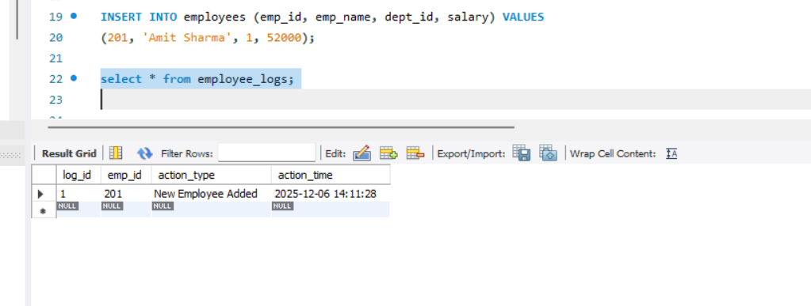
• Lab 2: Create a trigger to update the last_modified timestamp whenever an employee record is updated.
ALTER TABLE employees
ADD last_modified TIMESTAMP DEFAULT CURRENT_TIMESTAMP ON UPDATE CURRENT_TIMESTAMP;

DELIMITER $$

CREATE TRIGGER update_last_modified
BEFORE UPDATE ON employees
FOR EACH ROW
BEGIN
SET NEW.last_modified = NOW();
END $$

DELIMITER ;

select *from employees;

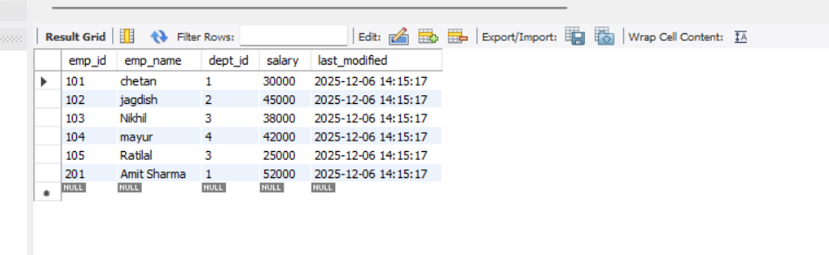
16. Introduction to PL/SQL Theory Questions:
1. What is PL/SQL, and how does it extend SQL's capabilities?
PL/SQL stands for Procedural Language / Structured Query Language.
It is Oracle’s programming extension to SQL.
While SQL can only perform single queries, PL/SQL adds programming features such as:
✔ Variables
✔ Conditions (IF…ELSE)
✔ Loops
✔ Functions
✔ Exception Handling
✔ Procedures
✔ Triggers
In short:
SQL = “What to do”
PL/SQL = “How to do it step-by-step”
PL/SQL allows us to write complex logic and execute multiple SQL statements in a block.
2. List and explain the benefits of using PL/SQL. LAB EXERCISES:
✔ 1. Better Performance
Multiple SQL statements are sent to the database in one block, reducing network traffic.
✔ 2. Improved Security
Business logic can be stored in procedures and functions so users don’t access raw tables.
✔ 3. Supports Procedural Features
Variables, loops, conditions, and exceptions make logic powerful and flexible.
✔ 4. Reusability
Stored procedures, functions, and packages can be reused.
✔ 5. Error Handling
PL/SQL provides an EXCEPTION section to handle runtime errors gracefully.
✔ 6. Integration
Can integrate easily with Oracle Forms, Reports, and other applications.

• Lab 1: Write a PL/SQL block to print the total number of employees from the employees table.
DELIMITER $$

CREATE PROCEDURE total_employees_proc()
BEGIN
SELECT COUNT(*) AS total_employees FROM employees;
END $$

DELIMITER ;

CALL total_employees_proc();
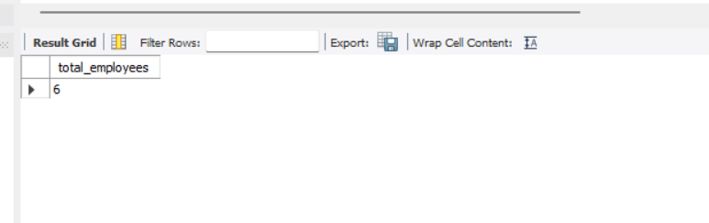
• Lab 2: Create a PL/SQL block that calculates the total sales from an orders table.
DELIMITER $$
CREATE PROCEDURE total_sales_proc()
BEGIN
SELECT SUM(amount) AS total_sales FROM orders;
END $$
DELIMITER ;

CALL total_sales_proc();
total_sales

250000

17. PL/SQL Control Structures
Theory Questions:
1. What are control structures in PL/SQL? Explain the IF-THEN and LOOP control structures.
Control structures are programming constructs that help control the flow of execution in PL/SQL blocks.
PL/SQL supports three types of control structures:
- Conditional control – IF, IF-THEN-ELSE, CASE
- Iterative control – LOOP, WHILE LOOP, FOR LOOP
- Sequential control – GOTO, NULL

✔ IF-THEN Control Structure
Used to execute statements conditionally.
Syntax:
IF condition THEN
statements;
END IF;
Example (PL/SQL):
IF salary > 50000 THEN
message := 'High salary employee';
END IF;

✔ LOOP Control Structure
Used to repeat statements multiple times.
Basic LOOP Syntax:
LOOP
statements;
EXIT WHEN condition;
END LOOP;

2. How do control structures in PL/SQL help in writing complex queries?
Control structures allow PL/SQL to:
✔ Apply business logic (conditions & loops)
✔ Perform multi-step operations
✔ Validate data before inserting or updating
✔ Process multiple records one by one
✔ Handle errors using EXCEPTION blocks
In short, PL/SQL turns SQL into a full programming language, enabling complex automation.

LAB EXERCISES:
• Lab 1: Write a PL/SQL block using an IF-THEN condition to check the department of an employee.
DELIMITER $$

CREATE PROCEDURE check_department(IN p_emp_id INT)
BEGIN
DECLARE v_dept INT;

SELECT dept_id INTO v_dept
FROM employees
WHERE emp_id = p_emp_id;

IF v_dept = 1 THEN
SELECT 'HR Department' AS result;
ELSEIF v_dept = 2 THEN
SELECT 'Finance Department' AS result;
ELSE
SELECT 'Other Department' AS result;
END IF;
END $$

DELIMITER ;
CALL check_department(201);
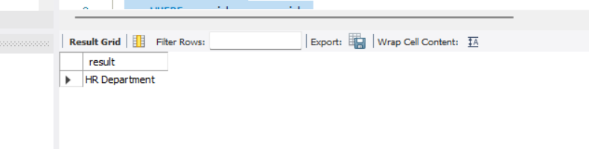
• Lab 2: Use a FOR LOOP to iterate through employee records and display their names.
DELIMITER $$

CREATE PROCEDURE list_employees()
BEGIN
DECLARE done INT DEFAULT FALSE;
DECLARE emp_name VARCHAR(100);

DECLARE emp_cursor CURSOR FOR
SELECT emp_name FROM employees;

DECLARE CONTINUE HANDLER FOR NOT FOUND SET done = TRUE;

OPEN emp_cursor;

read_loop: LOOP
FETCH emp_cursor INTO emp_name;
IF done THEN
LEAVE read_loop;
END IF;

SELECT emp_name AS employee_name;
END LOOP;

CLOSE emp_cursor;
END $$

DELIMITER ;
CALL list_employees();

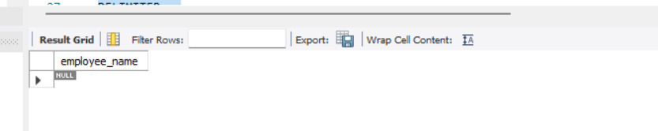
18. SQL Cursors
Theory Questions:
1. What is a cursor in PL/SQL? Explain the difference between implicit and explicit cursors.
A cursor is a pointer that lets you fetch and process rows returned by a query one row at a time.
- Implicit cursor
  - Automatically created by Oracle for single-row SQL statements (e.g., SELECT INTO, INSERT, UPDATE, DELETE).
  - You don’t declare it; you can access status via the SQL%ROWCOUNT, SQL%FOUND, SQL%NOTFOUND, etc.
  - Good for simple single-row operations.
- Explicit cursor
  - Declared by the programmer for queries that return multiple rows.
  - You control opening, fetching, and closing:
  - CURSOR c_emp IS SELECT emp_id, emp_name FROM employees;
  - OPEN c_emp;
  - FETCH c_emp INTO v_id, v_name;
  - CLOSE c_emp;
  - Use when you need row-by-row processing or custom looping over multiple rows.

2. When would you use an explicit cursor over an implicit one?
Use an explicit cursor when:
- The query returns multiple rows and you must process them one-by-one.
- You need precise control over fetch/loop behavior (e.g., conditional fetching, bulk processing, complex row-level logic).
- You want to DECLARE CURSOR with parameters or a specific ordering/locking strategy.
Implicit cursors are fine for simple single-row statements; explicit cursors are necessary for multi-row procedural logic.

LAB EXERCISES:
• Lab 1: Write a PL/SQL block using an explicit cursor to retrieve and display employee details.
DELIMITER $$

CREATE PROCEDURE show_employees_cursor()
BEGIN
DECLARE done INT DEFAULT 0;
DECLARE v_emp_id INT;
DECLARE v_emp_name VARCHAR(100);
DECLARE v_dept INT;
DECLARE v_salary INT;

DECLARE emp_cursor CURSOR FOR
SELECT emp_id, emp_name, dept_id, salary FROM employees ORDER BY emp_id;

DECLARE CONTINUE HANDLER FOR NOT FOUND SET done = 1;

OPEN emp_cursor;

read_loop: LOOP
FETCH emp_cursor INTO v_emp_id, v_emp_name, v_dept, v_salary;
IF done = 1 THEN
LEAVE read_loop;
END IF;
-- Show each row as a result set row (MySQL Workbench will display these SELECTs)
SELECT v_emp_id AS emp_id, v_emp_name AS emp_name, v_dept AS dept_id, v_salary AS salary;
END LOOP;

CLOSE emp_cursor;
END $$

DELIMITER ;

-- Call it:
CALL show_employees_cursor();

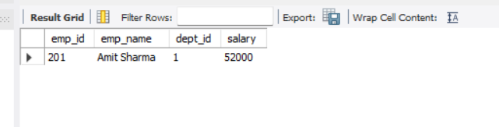
• Lab 2: Create a cursor to retrieve all courses and display them one by one.
DELIMITER $$

CREATE PROCEDURE list_courses_cursor()
BEGIN
DECLARE done INT DEFAULT 0;
DECLARE v_cid INT;
DECLARE v_name VARCHAR(200);
DECLARE v_dur VARCHAR(100);

DECLARE course_cur CURSOR FOR
SELECT course_id,course_name,course_duration
FROM courses
ORDER BY course_id;

DECLARE CONTINUE HANDLER FOR NOT FOUND SET done = 1;

OPEN course_cur;

course_loop: LOOP
FETCH course_cur INTO v_cid, v_name, v_dur;
IF done = 1 THEN
LEAVE course_loop;
END IF;

SELECT v_cid AS course_id, v_name AS course_name, v_dur AS course_duration;
END LOOP;

CLOSE course_cur;
END $$

DELIMITER ;

CALL list_courses_cursor();

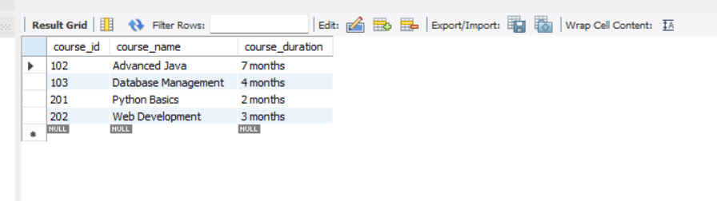

19. Rollback and Commit Savepoint
Theory Questions:
1. Explain the concept of SAVEPOINT in transaction management. How do ROLLBACK and COMMIT interact with savepoints?
✔ SAVEPOINT
A SAVEPOINT is a checkpoint inside a transaction.
It allows you to rollback part of the transaction without undoing the entire transaction.
Example:
SAVEPOINT sp1;
✔ ROLLBACK TO SAVEPOINT
- Undoes all operations after the savepoint.
- Keeps the work done before the savepoint.
Example:
ROLLBACK TO sp1;
✔ COMMIT
- Makes all changes permanent in the database.
- After COMMIT:
  - Savepoints are removed.
  - You cannot roll back to earlier savepoints.
Example:
COMMIT;

2. When is it useful to use savepoints in a database transaction?
Use savepoints when:
✔ You want to execute a long transaction but may need to undo a portion of it
✔ Running multiple insert/update/delete operations where some may fail
✔ Partial rollback is needed without losing the entire transaction
✔ Complex business logic requires checkpoints
✔ Testing database changes safely
Savepoints = partial undo without affecting all previous operations.

LAB EXERCISES:
• Lab 1: Perform a transaction where you create a savepoint, insert records, then rollback to the savepoint.
SET autocommit = 0;

START TRANSACTION;

INSERT INTO employees (emp_id, emp_name, dept_id, salary)
VALUES (201, 'Test User 1', 1, 40000);

SAVEPOINT sp1;

INSERT INTO employees (emp_id, emp_name, dept_id, salary)
VALUES (202, 'Test User 2', 2, 50000);

-- Rollback the second insert only
ROLLBACK TO sp1;

COMMIT;
• Lab 2: Commit part of a transaction after using a savepoint and then rollback the remaining changes.
SET autocommit = 0;

START TRANSACTION;

INSERT INTO employees (emp_id, emp_name, dept_id, salary)
VALUES (301, 'User A', 1, 55000);

SAVEPOINT sp1;

INSERT INTO employees (emp_id, emp_name, dept_id, salary)
VALUES (302, 'User B', 2, 60000);

COMMIT; -- commits both 301 and 302 so far

-- Continue with more changes
INSERT INTO employees (emp_id, emp_name, dept_id, salary)
VALUES (303, 'User C', 3, 50000);

INSERT INTO employees (emp_id, emp_name, dept_id, salary)
VALUES (304, 'User D', 1, 70000);

-- Rollback the last 2 inserts only
ROLLBACK;

